Instruction:

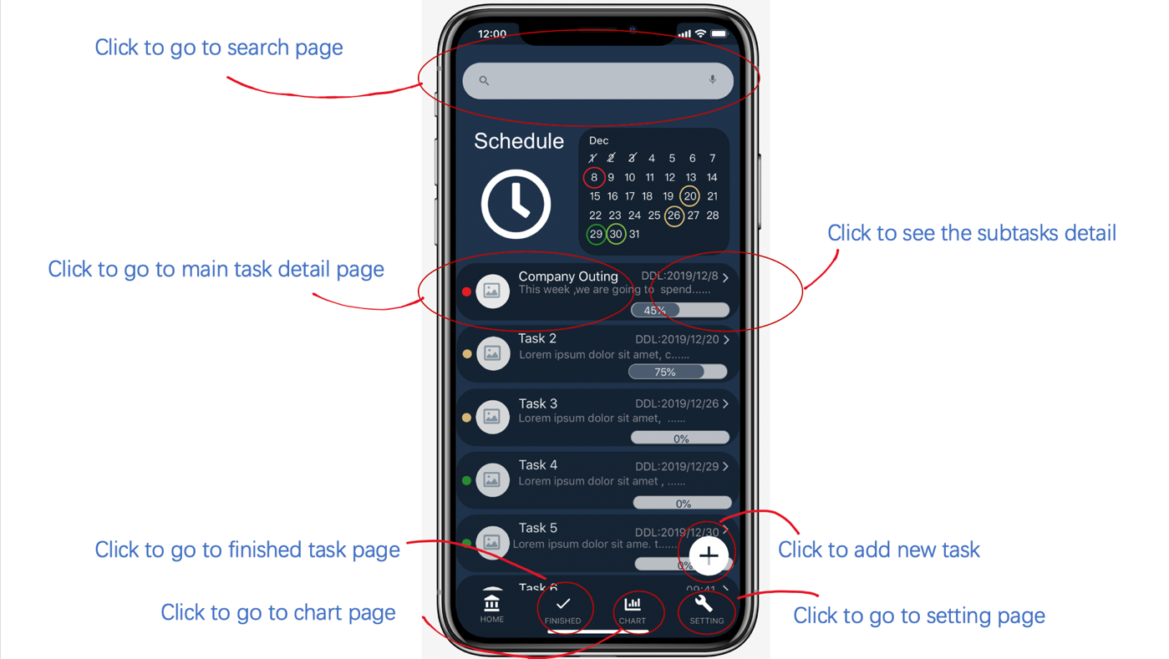

1. The home page can lead you to all the features that my design have
2. Every page has a back to home page button, some are optional in case you do not want to check this feature anymore , some are mandatory, it means that you have already explored all the animation in that feature. And you have to click “Back to home page” button.

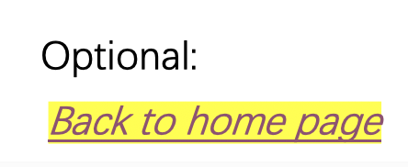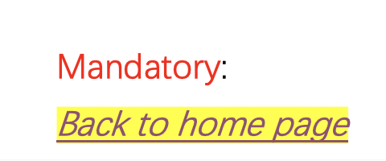

1. If anything unexpected happened, click back to home and try that very feature again.
2. Further instruction will be seen in the ppt.
3. The button style show below is clickable

Example：